**Challenge 1 - Steve's Car Showroom**

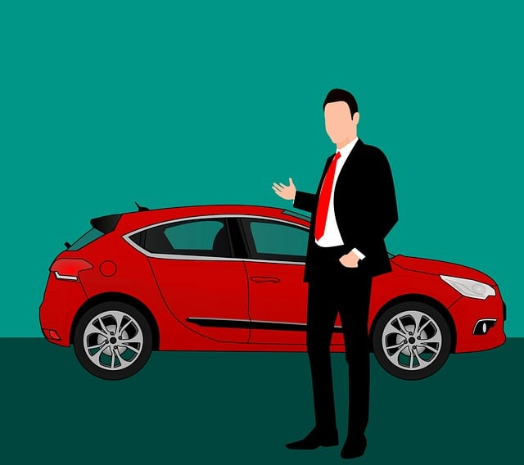

**Intro**

Steve runs a top-end car showroom but his data analyst has just quit and left him without his crucial insights.

Can you analyse the following data to provide him with all the answers he requires?

**Tables**

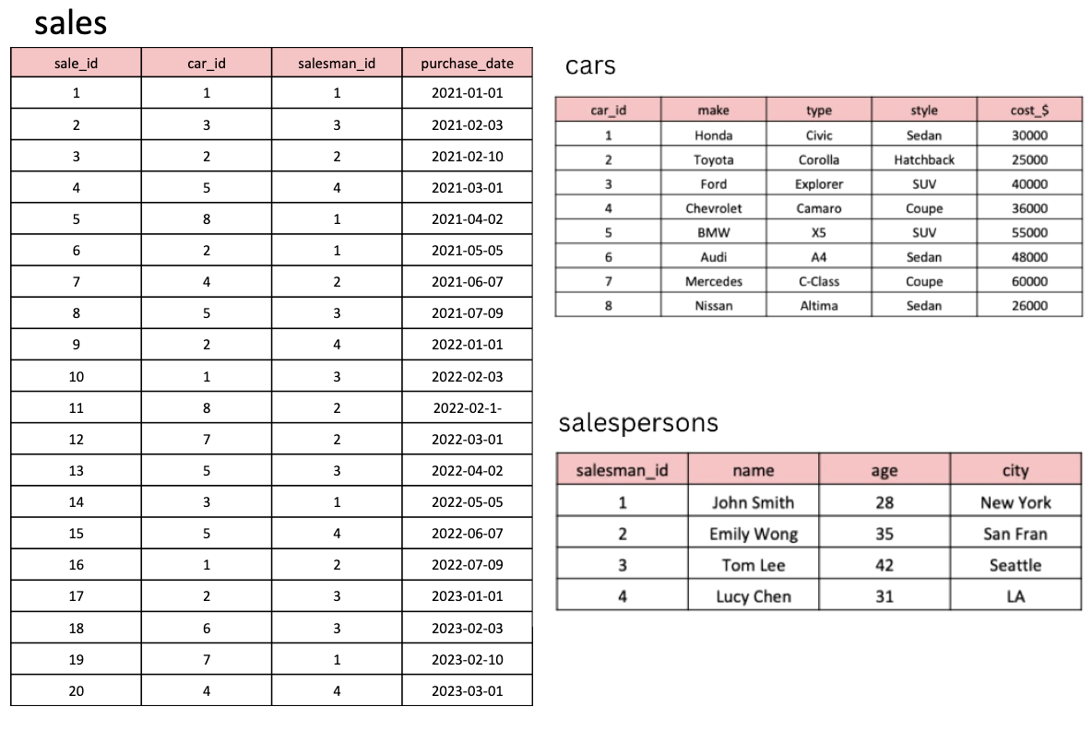

CREATE TABLE cars (

car_id INT PRIMARY KEY,

make VARCHAR(50),

type VARCHAR(50),

style VARCHAR(50),

cost_$ INT

);

--------------------

INSERT INTO cars (car_id, make, type, style, cost_$)

VALUES (1, 'Honda', 'Civic', 'Sedan', 30000),

(2, 'Toyota', 'Corolla', 'Hatchback', 25000),

(3, 'Ford', 'Explorer', 'SUV', 40000),

(4, 'Chevrolet', 'Camaro', 'Coupe', 36000),

(5, 'BMW', 'X5', 'SUV', 55000),

(6, 'Audi', 'A4', 'Sedan', 48000),

(7, 'Mercedes', 'C-Class', 'Coupe', 60000),

(8, 'Nissan', 'Altima', 'Sedan', 26000);

--------------------

CREATE TABLE salespersons (

salesman_id INT PRIMARY KEY,

name VARCHAR(50),

age INT,

city VARCHAR(50)

);

--------------------

INSERT INTO salespersons (salesman_id, name, age, city)

VALUES (1, 'John Smith', 28, 'New York'),

(2, 'Emily Wong', 35, 'San Fran'),

(3, 'Tom Lee', 42, 'Seattle'),

(4, 'Lucy Chen', 31, 'LA');

--------------------

CREATE TABLE sales (

sale_id INT PRIMARY KEY,

car_id INT,

salesman_id INT,

purchase_date DATE,

FOREIGN KEY (car_id) REFERENCES cars(car_id),

FOREIGN KEY (salesman_id) REFERENCES salespersons(salesman_id)

);

--------------------

INSERT INTO sales (sale_id, car_id, salesman_id, purchase_date)

VALUES (1, 1, 1, '2021-01-01'),

(2, 3, 3, '2021-02-03'),

(3, 2, 2, '2021-02-10'),

(4, 5, 4, '2021-03-01'),

(5, 8, 1, '2021-04-02'),

(6, 2, 1, '2021-05-05'),

(7, 4, 2, '2021-06-07'),

(8, 5, 3, '2021-07-09'),

(9, 2, 4, '2022-01-01'),

(10, 1, 3, '2022-02-03'),

(11, 8, 2, '2022-02-10'),

(12, 7, 2, '2022-03-01'),

(13, 5, 3, '2022-04-02'),

(14, 3, 1, '2022-05-05'),

(15, 5, 4, '2022-06-07'),

(16, 1, 2, '2022-07-09'),

(17, 2, 3, '2023-01-01'),

(18, 6, 3, '2023-02-03'),

(19, 7, 1, '2023-02-10'),

(20, 4, 4, '2023-03-01');

#1. What are the details of all cars purchased in the year 2022?

select *

from cars c

join sales s on c.car_id=s.car_id

WHERE YEAR(s.purchase_date)=2022;

#2. What is the total number of cars sold by each salesperson?

select sp.salesman_id, sp.name, count(s.sale_id) as cars_sold

from salespersons sp join sales s

on sp.salesman_id=s.salesman_id

group by s.salesman_id

order by cars_sold desc;

#3. What is the total revenue generated by each salesperson?

select sp.salesman_id, sp.name, sum(c.cost_$) as revenue_generated

from salespersons sp join sales s

on sp.salesman_id=s.salesman_id

join cars c

on s.car_id=c.car_id

group by s.salesman_id

order by revenue_generated desc;

#4. What are the details of the cars sold by each salesperson?

select sp.*, c.*

from salespersons sp join sales s

on sp.salesman_id=s.salesman_id

join cars c

on s.car_id=c.car_id;

#5. What is the total revenue generated by each car type?

select c.type, sum(c.cost_$) as revenue_generated

from sales s

join cars c

on s.car_id=c.car_id

group by c.type

order by revenue_generated desc;

#6. What are the details of the cars sold in the year 2021 by salesperson 'Emily Wong'?

select s.salesman_id, sp.name, c.*

from salespersons sp join sales s

on sp.salesman_id=s.salesman_id

join cars c

on s.car_id=c.car_id

where year(s.purchase_date)=2021 and sp.name='Emily Wong';

#7. What is the total revenue generated by the sales of hatchback cars?

select c.style, sum(c.cost_$) as revenue_generated

from sales s

join cars c

on s.car_id=c.car_id

where c.style='Hatchback';

#8. What is the total revenue generated by the sales of SUV cars in the year 2022?

select c.style, sum(c.cost_$) as revenue_generated

from sales s

join cars c

on s.car_id=c.car_id

where c.style='SUV' and year(purchase_date)=2022;

#9. What is the name and city of the salesperson who sold the most number of cars in the year 2023?

select sp.name, sp.city, count(s.sale_id) as cars_sold

from salespersons sp join sales s

on sp.salesman_id=s.salesman_id

where year(s.purchase_date)=2023

group by s.salesman_id

order by cars_sold desc limit 1;

#10. What is the name and age of the salesperson who generated the highest revenue in the year 2022?

select sp.name, sp.age, sum(c.cost_$) as revenue_generated

from salespersons sp join sales s

on sp.salesman_id=s.salesman_id

join cars c

on s.car_id=c.car_id

where year(purchase_date)=2022

group by s.salesman_id

order by revenue_generated desc limit 1;